**Welcome Home Page of ICIN Bank Application:**

* Welcome page have option for Admin Login, User Login and create account option If any user new in bank

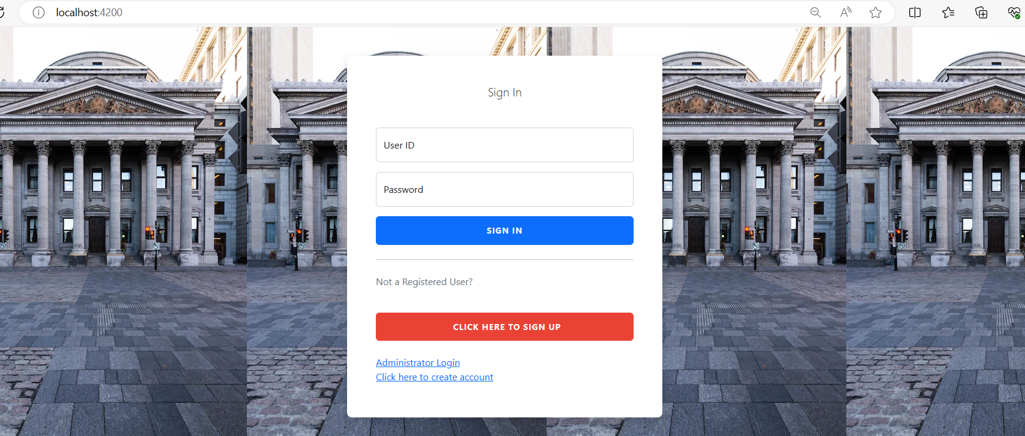

**User Login page:**

* User Can login if he is existing user or else create account option for new User. let’s go with **create account option**:
* Once You added all the details and clicked on submit your account is created.

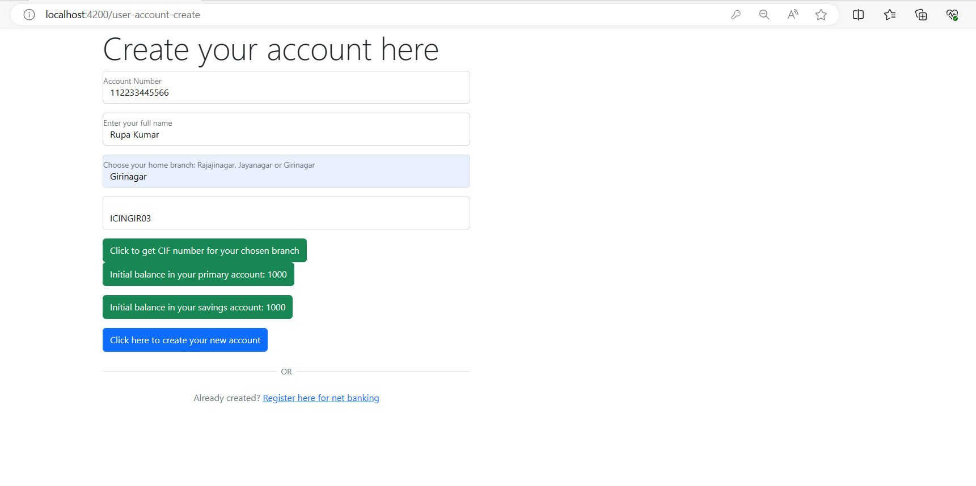

* After Successful registration now user can be requested for **Net banking.**

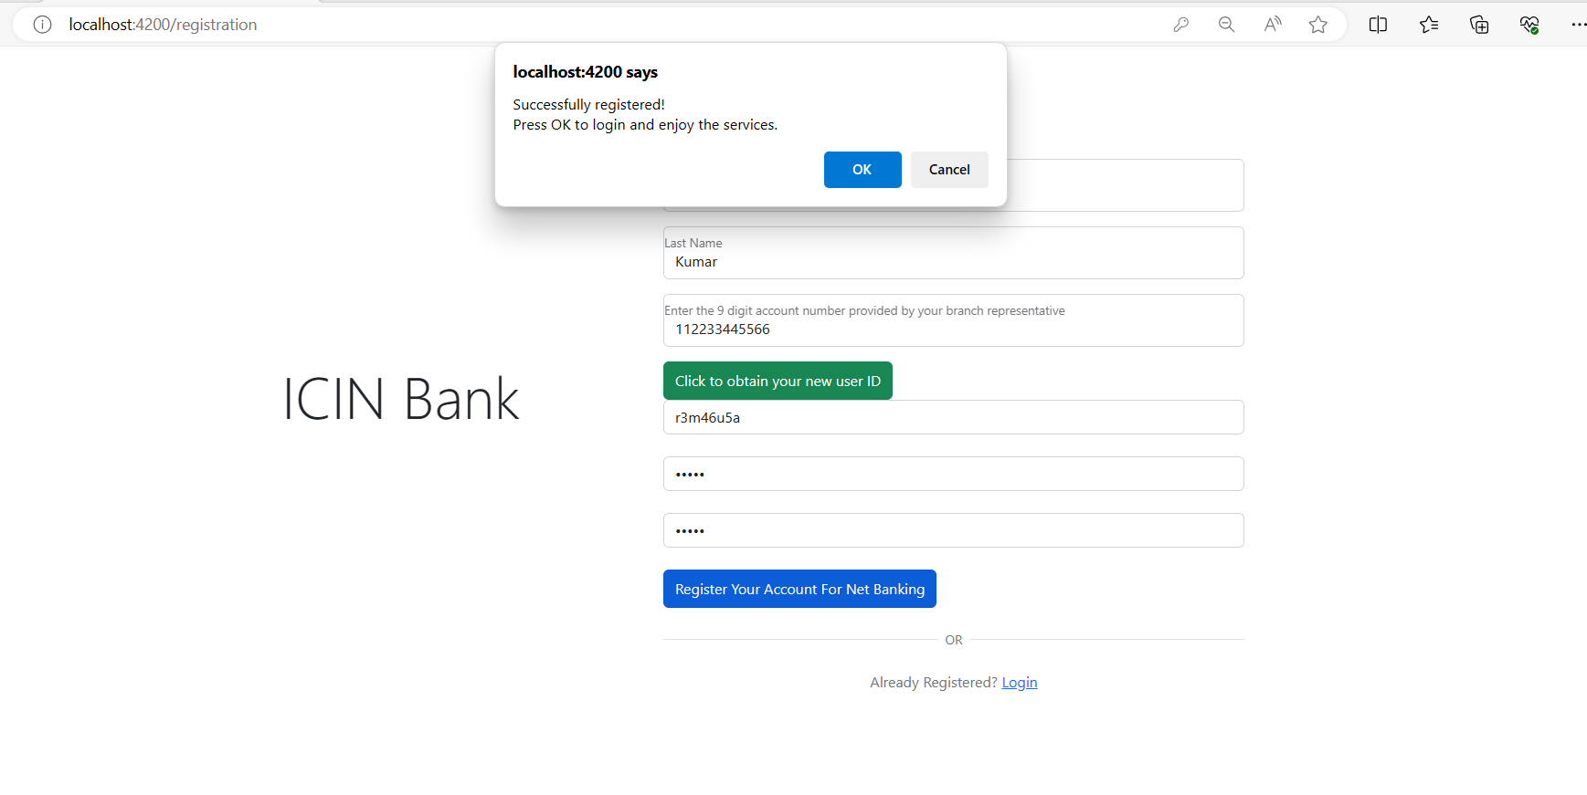

* Now user have there userId and password after account creation, lets go with **login option and use id and password** which entered on account creation time:

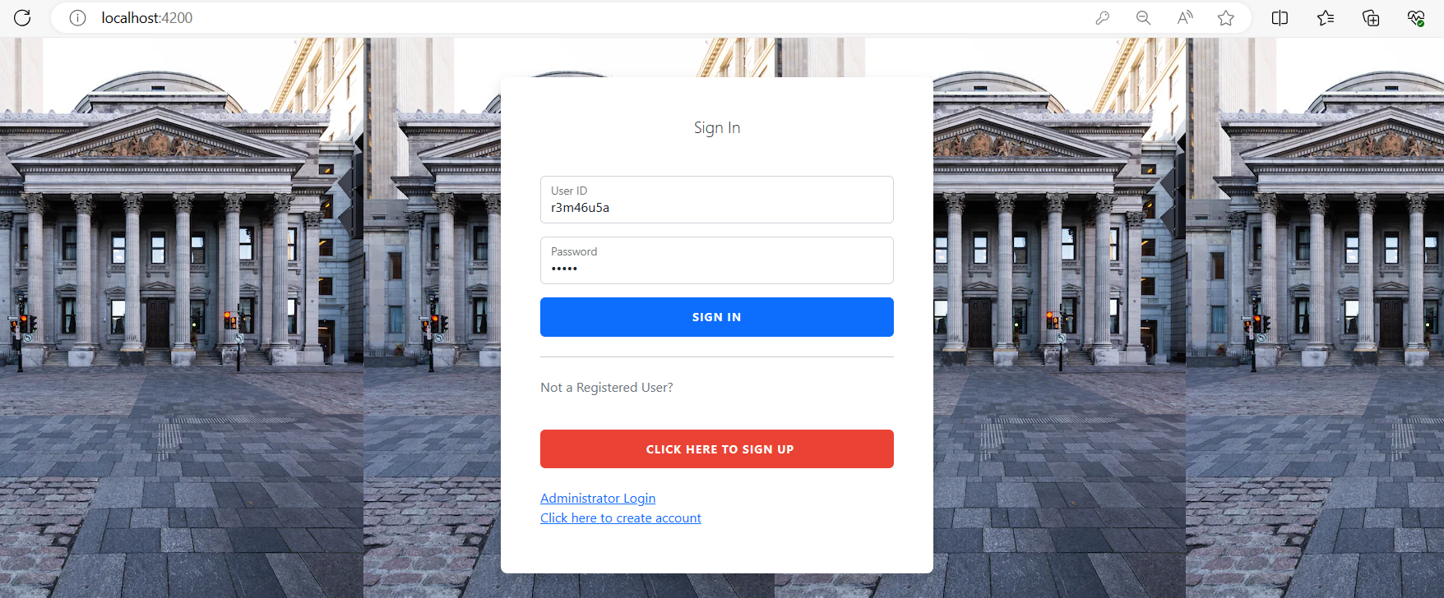

* After Successful login user will be redirected to **User Dashboard page** where user can perform below mentioned list of operation:
* View My Account:
* Manage Cheque Books
* Passbook
* Net Banking
* Deposit
* Withdrawal
* My Profile

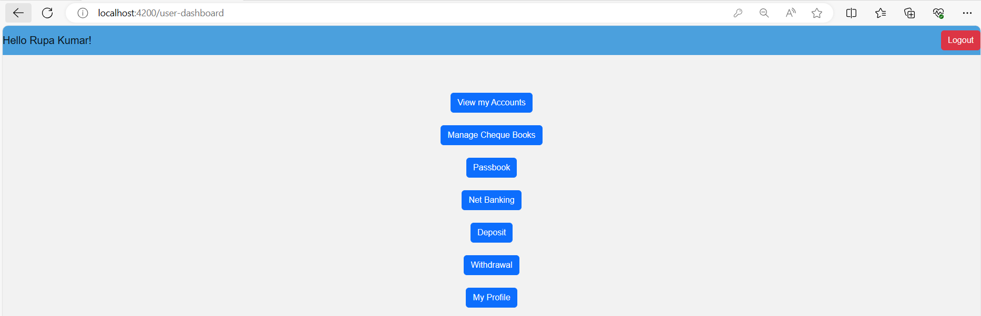

* Let’s go with first option “**View My Account**”:

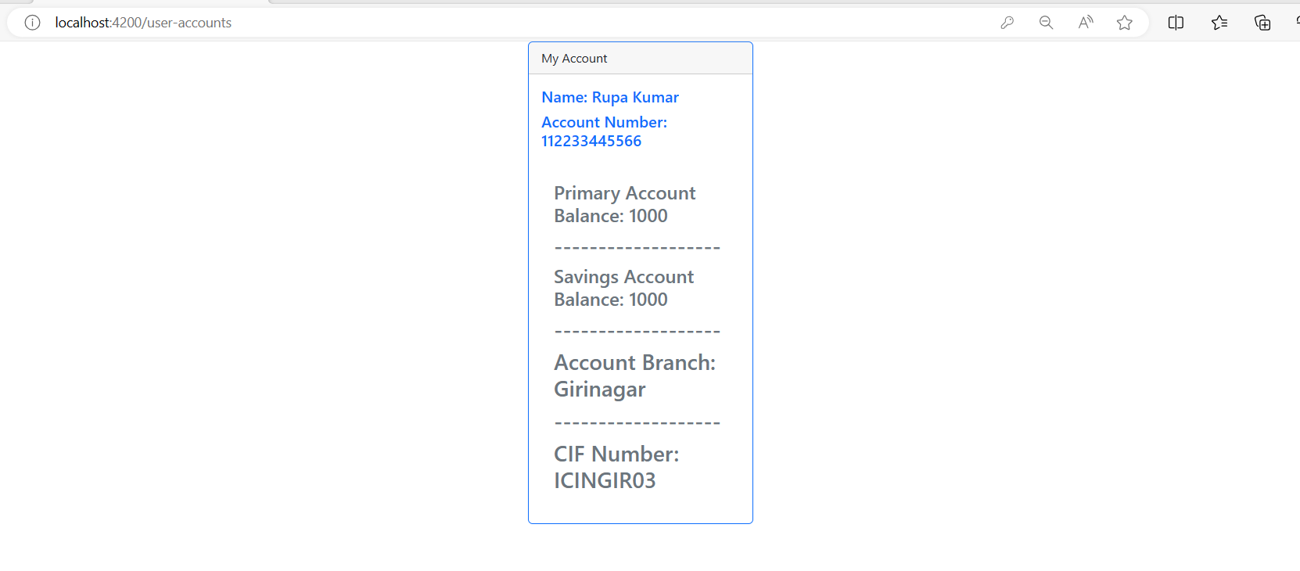

* Let’s go with next option “**Manage Check Book**”: Here user can Request for check Book and See the details and status of cheque book. Lets requested for cheque book:

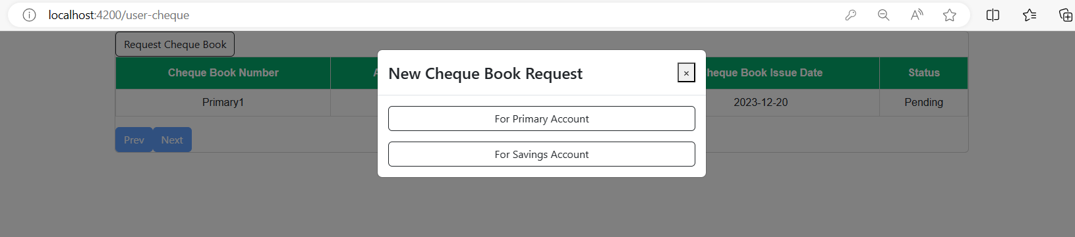

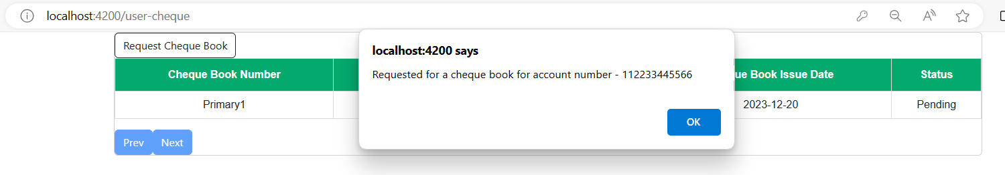

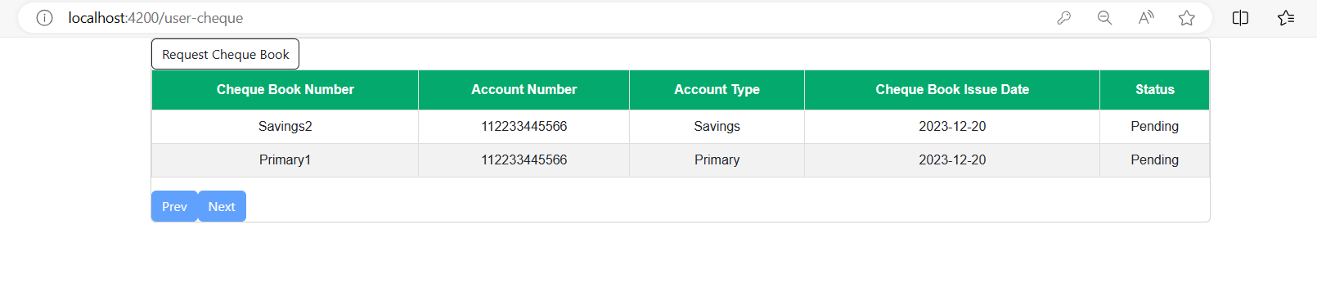

* Let’s go with next option “**Passbook**”: Initial User passbook is empty ,When user will any transaction that details will appear here :

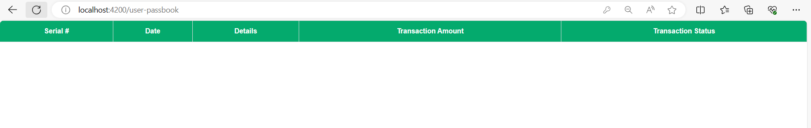

* After Performing 2 transaction:

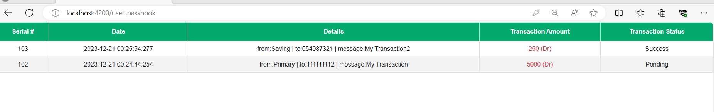

* Let’s go with next option “**Net Banking**”: As user already request for net banking and its pending for approval from admin side:

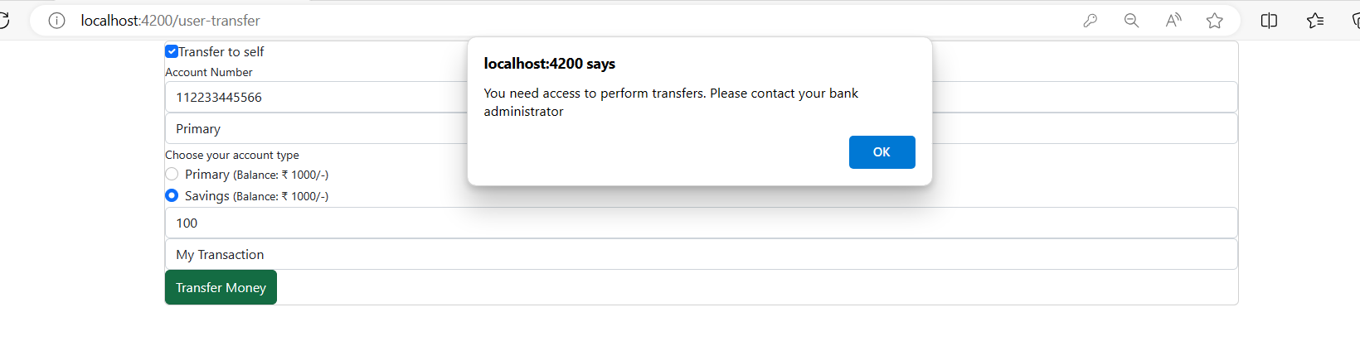

* Let’s go with next option “**Deposit**”:
* User can Deposit amount in his **primary** account as shown below:

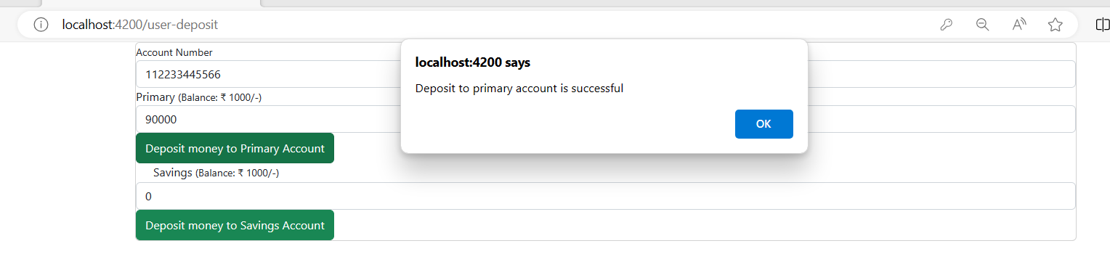

* User can Deposit amount in his **Saving** account as shown below:

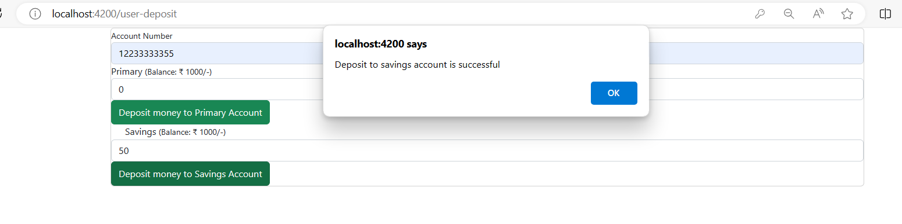

* Let’s go with next option “**Withdrawal**”:
* User can withdraw amount in his **primary** account as shown below:

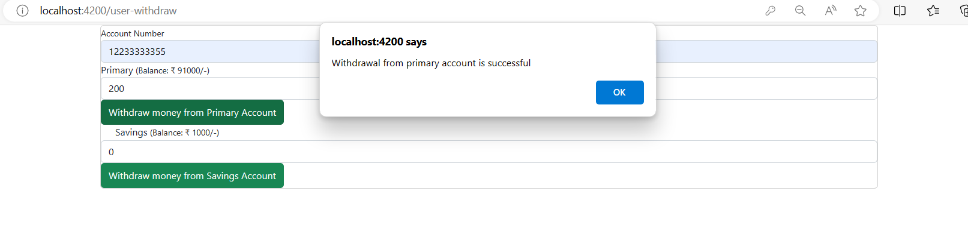

* User can withdraw amount in his **saving** account as shown below:

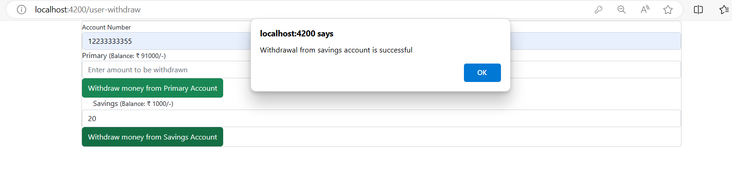

* Let’s go with next option “**My Profile**”: Using this option user can view there details as well update the password:

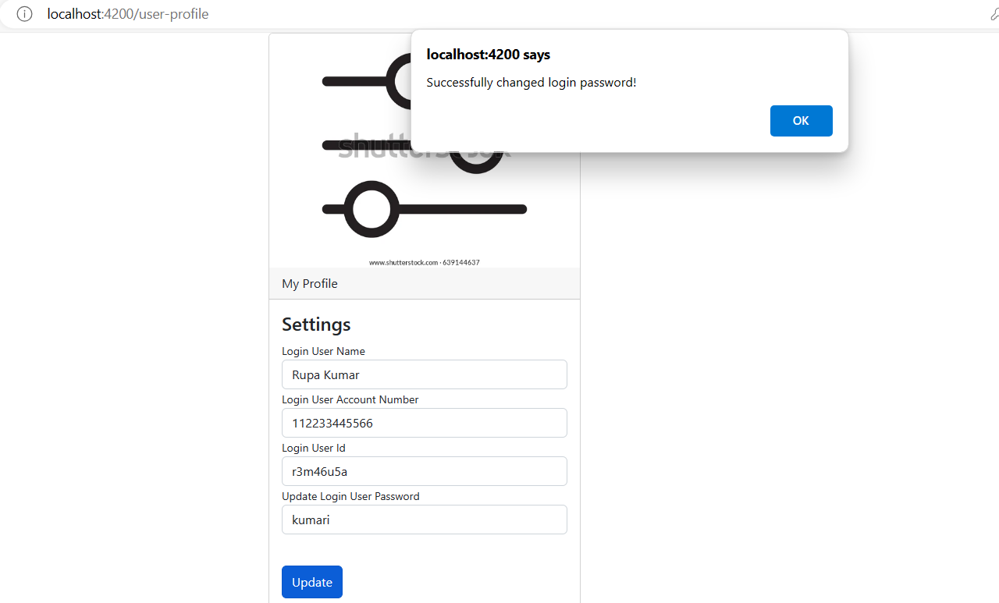

* Now All operation performed by user lets logout and go with admin task:

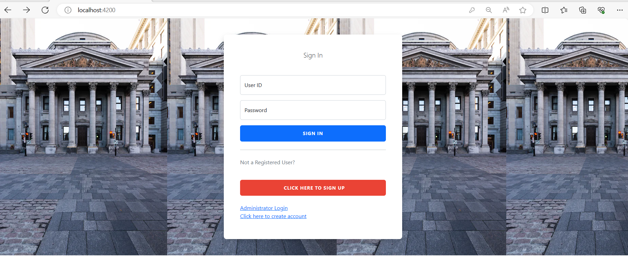

**Admin Login page:**

* Checks Admin Credentials Correct or not and for incorrect credential reject the request and show message:

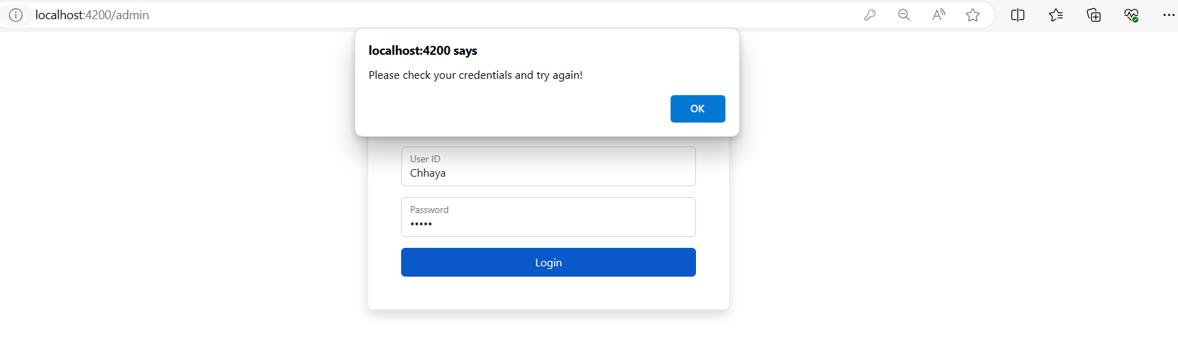

* For Correct Credential Allow admin to go the Admin Dashboard page and Admin Have Below mention Authorities:
* Approve the Cheque Book Request
* Approve Transaction
* Manage Blocked Account
* Enable net Banking
* Block Threat Accounts

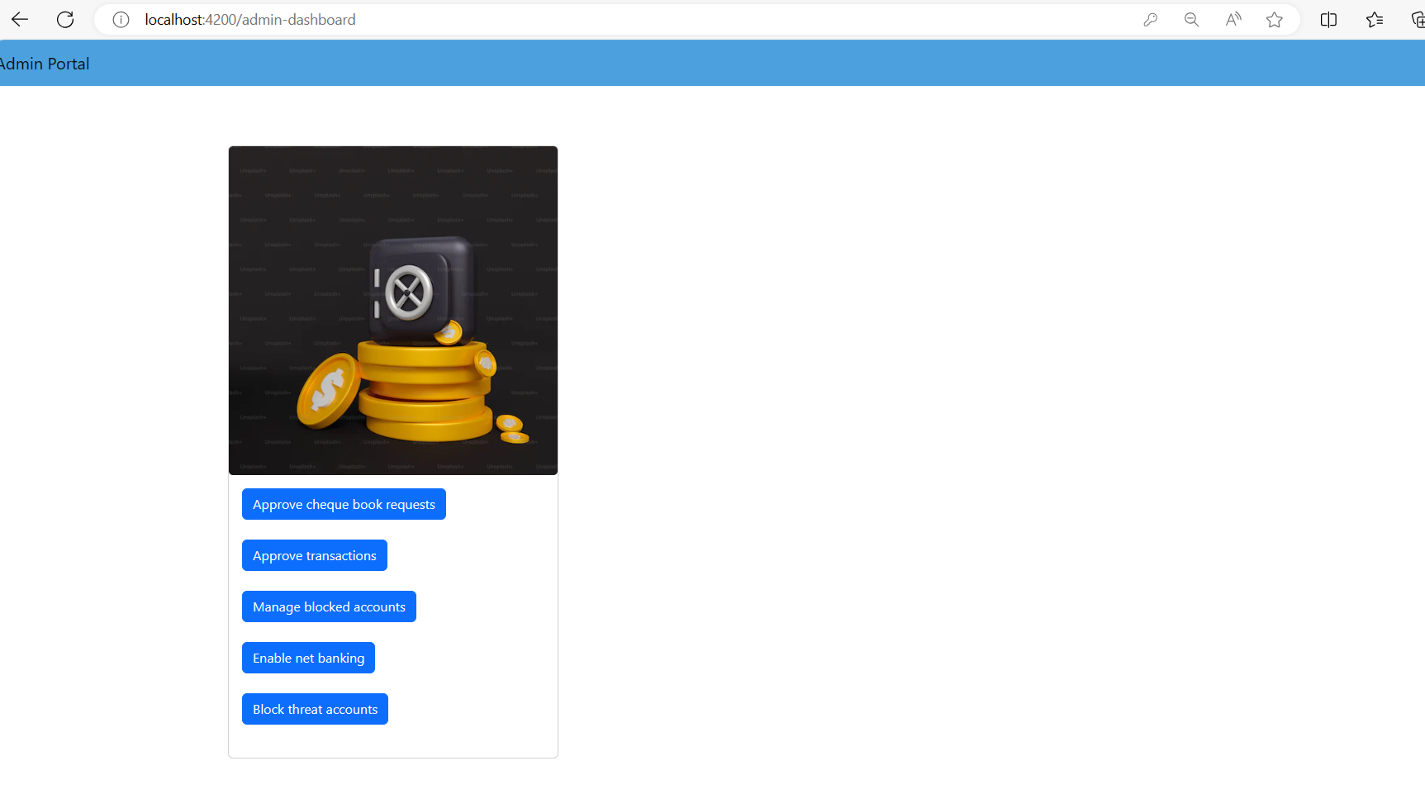

* Lets go with first option “**Approve the cheque book request**”: Admin have below list of request for cheque book request and have authority to approve the cheque book request:

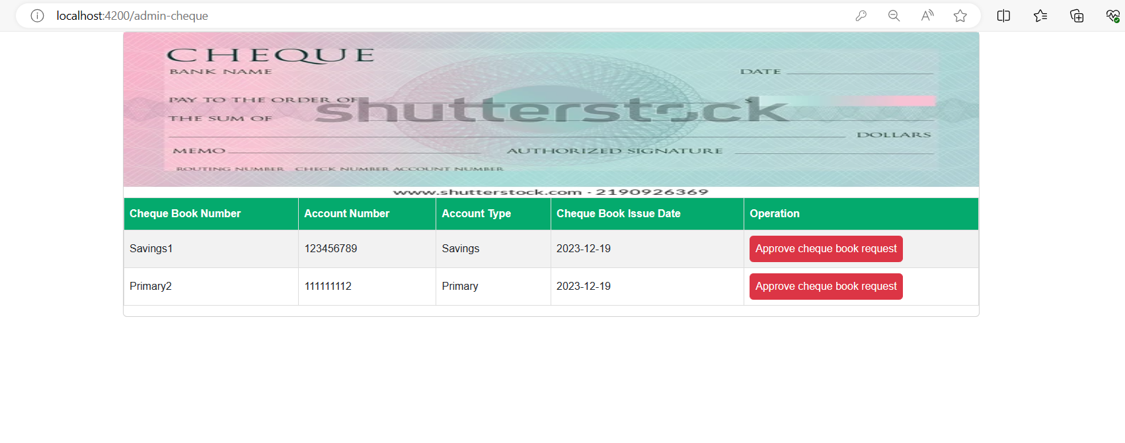 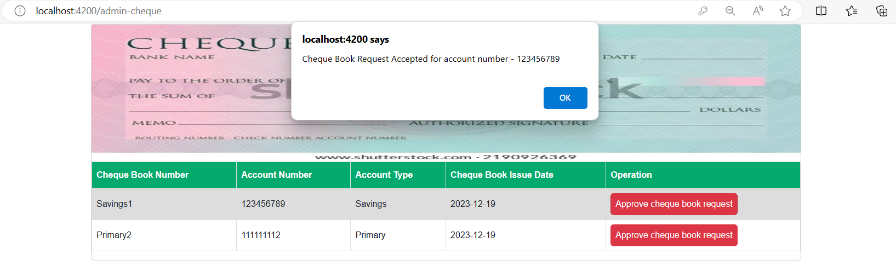

* Let’s go with first option “Approve Transaction”: Admin have below list of requests for Approve

Transaction and have authority to unblock the user:

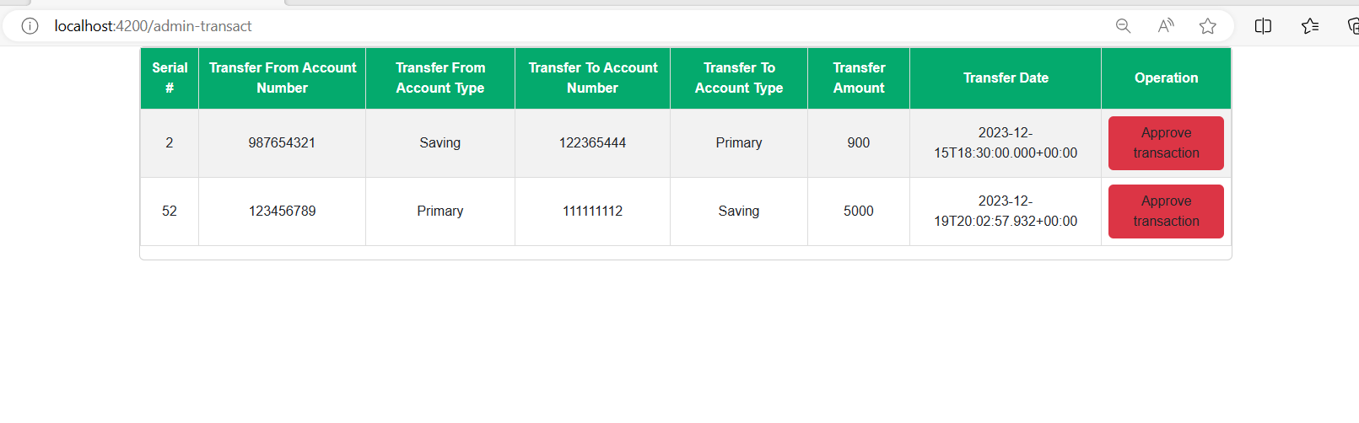

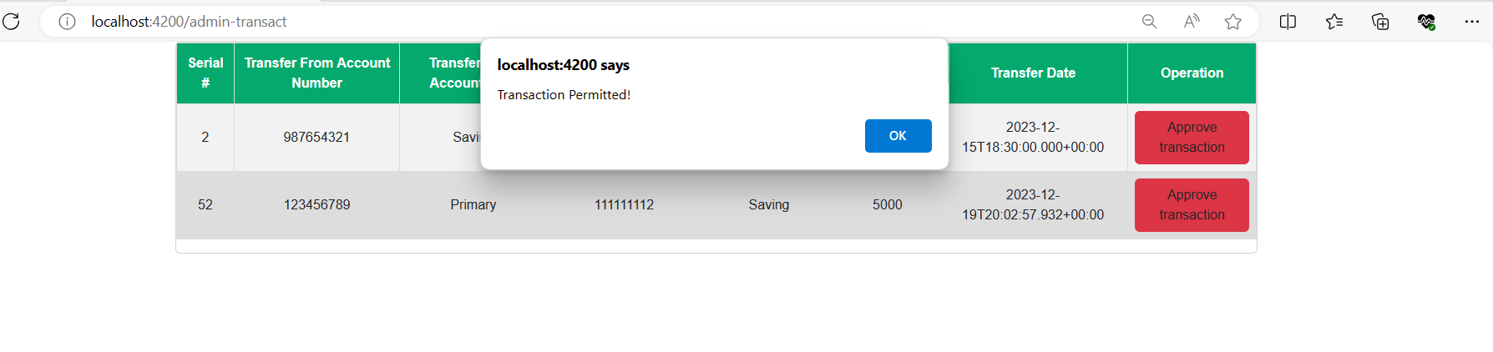

* Let’s go with first option “Manage Blocked Account”: Admin have below list of requests for Manage Blocked Account and have authority to unblock.

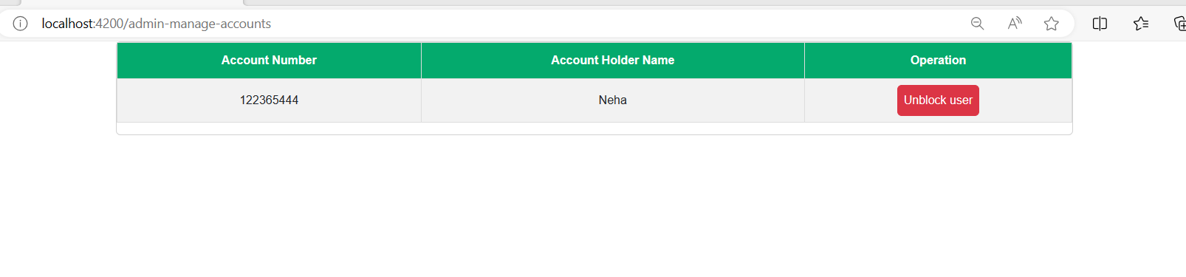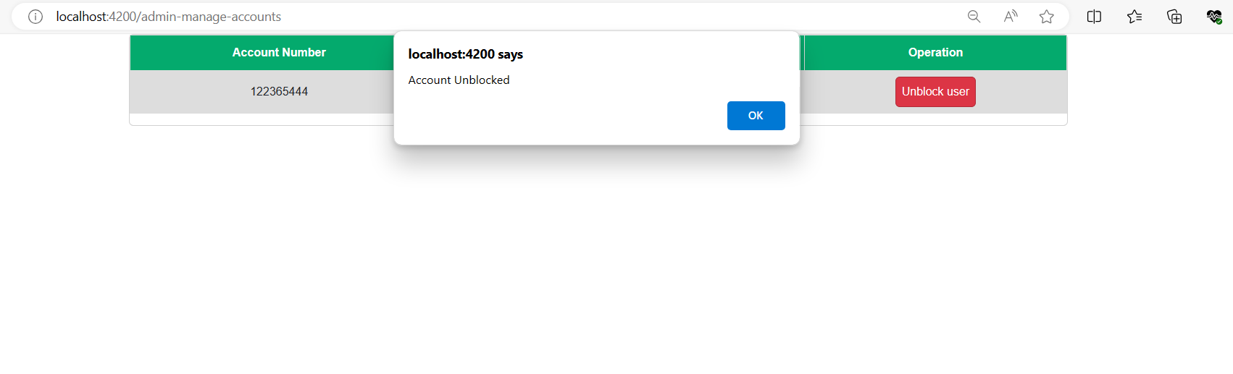

* Let’s go with first option “Enable net Banking”: Admin have below list of requests for Enable net Banking and have authority to provide permission for net banking:

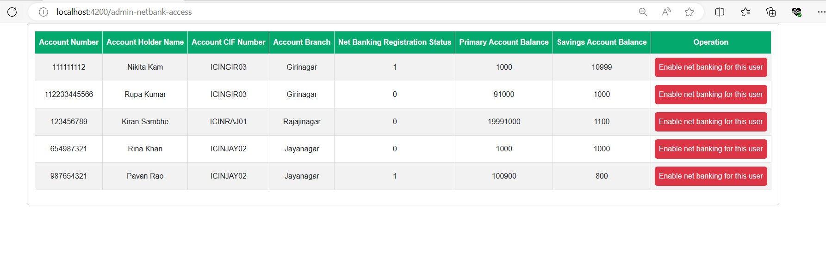

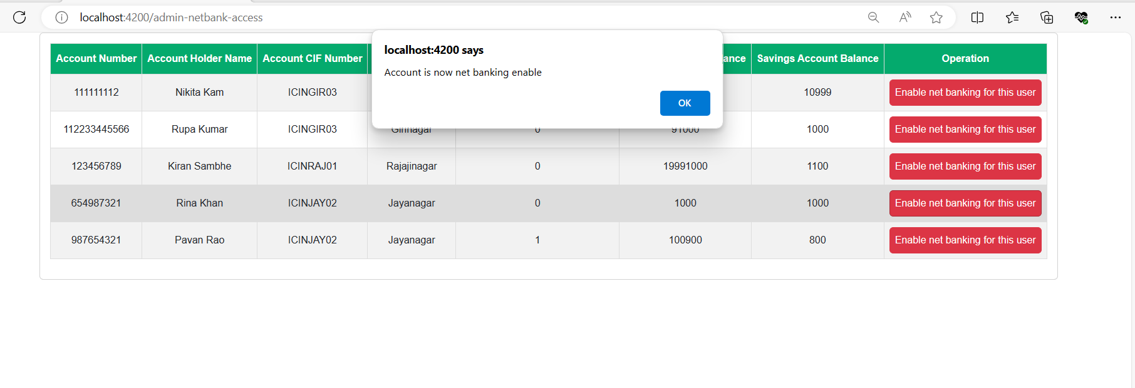

* Let’s go with first option “**Block Threat Accounts**”: Admin have below list of requests for Block Threat Accounts and have authority to block any user:

